

Practices for Secure Software Report

Table of Contents
Document Revision History 3
Client 3
Instructions 3
Developer 4
1. Algorithm Cipher 4
2. Certificate Generation 4
3. Deploy Cipher 4
4. Secure Communications 4
5. Secondary Testing 4
6. Functional Testing 4
7. Summary 4
8. Industry Standard Best Practices 4

Document Revision History

Version | Date | Author | Comments
1.0 | 6/18/26 | Sarah See | Began Project, worked on cipher
2.0 | 6/21/26 | Sarah See | Generated certificate, did write up.

Client



Developer
Sarah See

Algorithm Cipher

For Artemis Financial, I used SHA-256 as the cryptographic hashing algorithm for the checksum verification. SHA-256 is part of the SHA-2 family and creates a fixed 256-bit hash value from input data. This is useful for this project because Artemis Financial needed a way to verify that data had not been changed during communication. If even one character in the original data changes, the checksum result will also change, which makes SHA-256 useful for checking data integrity.

SHA-256 is different from normal encryption because it is a one-way hashing function. Encryption is meant to be reversed with the correct key, but hashing is not meant to be reversed. Symmetric encryption uses the same secret key to encrypt and decrypt information, while asymmetric encryption uses a public key and a private key. Random numbers are also important in security because they can help make keys, certificates, and secure sessions harder to predict. In this project, the SSL certificate and HTTPS configuration helped protect communication, while SHA-256 was used to verify the data string and produce a checksum.

Hashing algorithms have changed over time as older options became less secure. Algorithms like MD5 and SHA-1 were once common, but they are no longer recommended for secure systems because attackers have found ways to create collisions. A collision happens when two different inputs produce the same hash value. SHA-256 is still considered a stronger modern option and is widely used for secure checksum verification. Because Artemis Financial handles sensitive financial information, using SHA-256 helps support secure coding practices and provides a stronger way to verify data integrity.

Certificate Generation

The self-signed SSL certificate was generated using Java Keytool and exported successfully. The certificate identifies Sarah See as both the issuer and subject because it is self-signed for development and testing purposes.

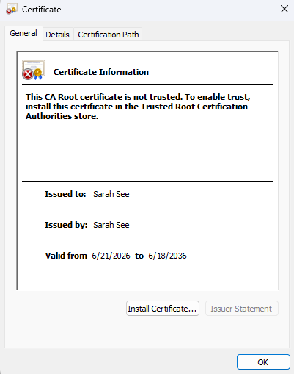

Deploy Cipher
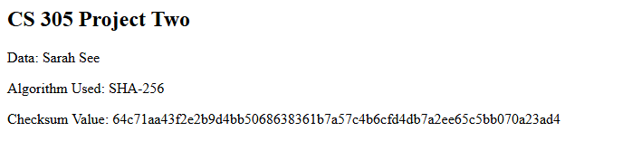

Secure Communications

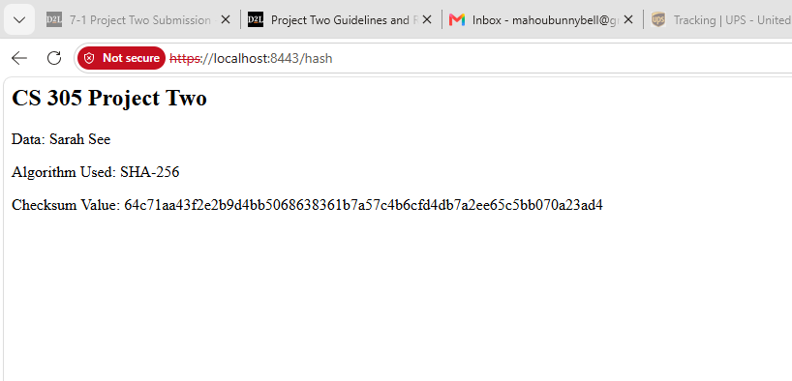
The browser displays the page over HTTPS, confirming the connection is encrypted. The "Not secure" label shown in the address bar is expected behavior for a self-signed certificate — Chrome flags it because the certificate's issuer (Sarah See) is not registered in the browser's trusted root certificate authority store, not because the connection itself is unencrypted. In a production environment, this self-signed certificate would be replaced with one issued by a trusted Certificate Authority to remove that warning. For this assignment's scope, the HTTPS protocol and TLS encryption are functioning correctly, which satisfies Artemis Financial's requirement for secure communications.

Secondary Testing
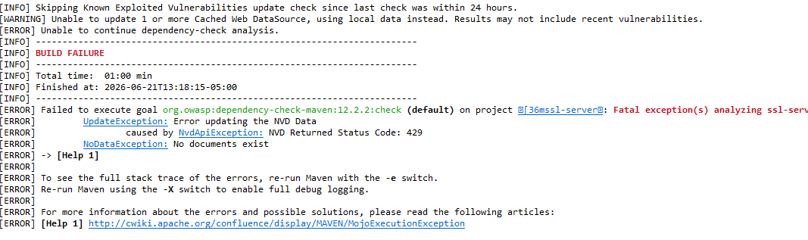
Secondary testing was performed by running the OWASP Dependency-Check Maven plugin after the application was refactored. The Maven build began the dependency-check process, but the scan could not fully complete because the NVD API returned a 429 status code. This indicates that the external vulnerability database rate-limited the request. Dependency-Check retried the request multiple times, but it was unable to update the NVD data and reported that no documents existed for analysis.

This issue was caused by the external NVD data source and not by the refactored application code. The output was documented as part of the secondary testing process. Once the NVD rate limit resets or an NVD API key is available, the Dependency-Check scan should be rerun to generate a complete vulnerability report.

Functional Testing

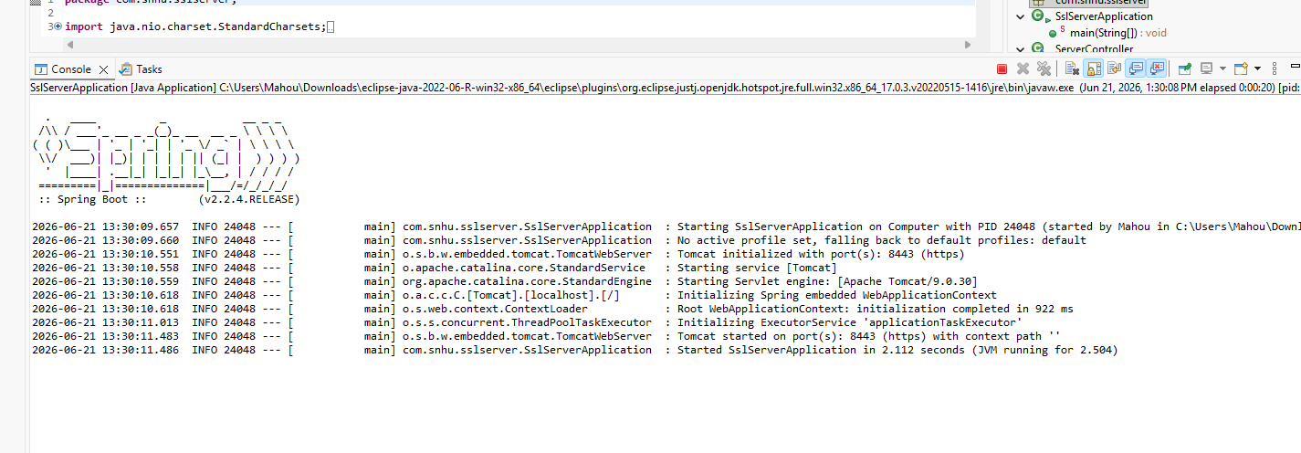

Summary

During this project, I followed the vulnerability assessment process by reviewing the application's architecture, implementing security enhancements, and testing the application after the changes were made. The primary areas addressed from the vulnerability assessment process flow were Cryptography, Client/Server security, Code Quality, and Code Review. SHA-256 hashing was implemented to provide checksum verification and improve data integrity. HTTPS was enabled through the use of a self-signed SSL certificate to secure communication between the client and server. The application code was reviewed and refactored to ensure the new security features functioned correctly.

After the security enhancements were implemented, functional testing was performed to verify that the application executed successfully and that the checksum functionality operated as expected. Secondary testing was also performed using OWASP Dependency-Check to identify potential vulnerabilities within project dependencies (Although the NVD API was giving me issues with the rate limit on that). Through this process, the application was strengthened by improving data integrity, securing communications, and following secure software development practices. These changes help Artemis Financial better protect sensitive financial information and reduce potential security risks.

Industry Standard Best Practices

To maintain Artemis Financial's security while adding the new features, I tried to follow common secure coding practices instead of only making the changes needed for the program to work. For encryption, I used SHA-256 because it is a widely accepted hashing algorithm and is part of the NIST-approved SHA-2 family. I also enabled HTTPS using TLS/SSL so that data sent between the client and server would be encrypted instead of being transmitted over unsecured HTTP. In addition, I used OWASP Dependency-Check to scan the project's third-party libraries for known vulnerabilities rather than assuming all dependencies were secure. Along with the automated scan, I reviewed the code manually before and after making changes to look for possible security issues that the tool might miss.
These practices help protect Artemis Financial because the company works with sensitive financial information such as savings, retirement, investment, and insurance data. If a security breach occurred, customer information could be exposed and the company could face reputational damage or legal consequences. Using established security standards and tools helps reduce these risks and makes the application easier for other developers to maintain and review in the future. Overall, following these secure coding practices helps support Artemis Financial's goal of making security a shared responsibility throughout the organization.

